Group Project – Build A Web Application

Name and student numbers of all team members and Web Application Name

Student Name 1 __Mert Kaya ______________Student Number 1_______2990074_____________________
Student Name 2 __Oguz Sarac _____________Student Number 2_______2988989_____________________
Student Name 3 __Sergey Kurapov _________Student Number 3_______3025265_____________________
Name of Web Application ____Fit&Life_________________________________

The 5 main pages
Screen shots and a line of explanation for each.

Home
Homepage. First we have a landing section with a big image and caption. After, you can learn information about Fit&Life and some features.
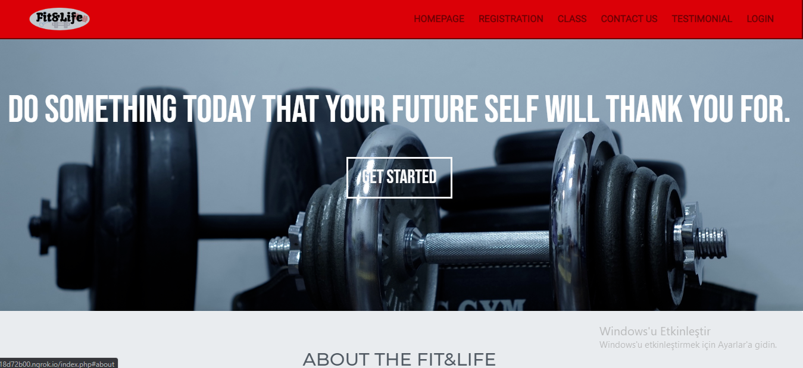

Registration
We have three different option. Which are Bronze, Silver and Gold Membership with a different price.
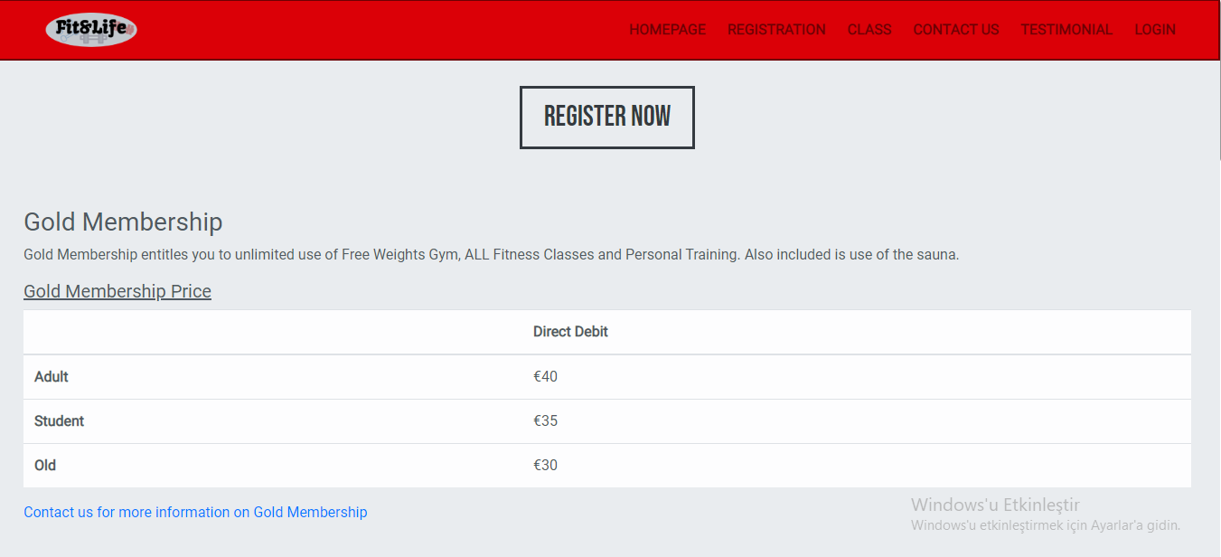

Classes
For classes, we separated the classes as columns. If you click on the link for classes you can see detailed information.
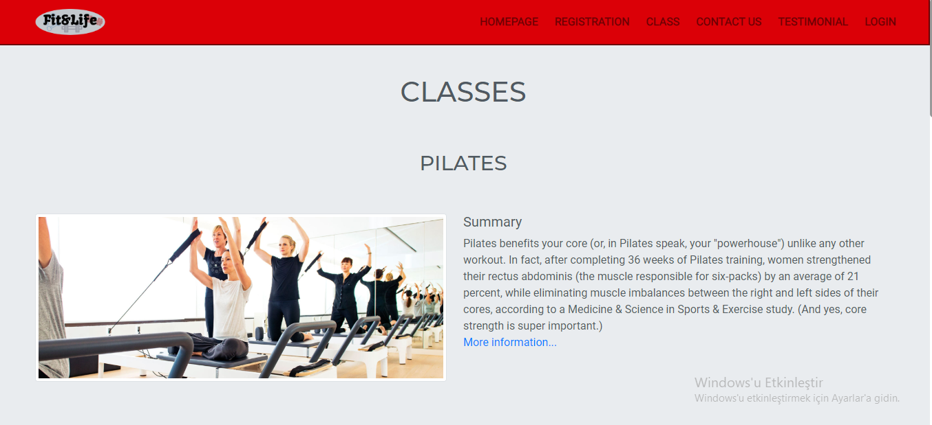

Testimonial
Testimonial page, we are showing members feedback or feelings about the classes and the gym.
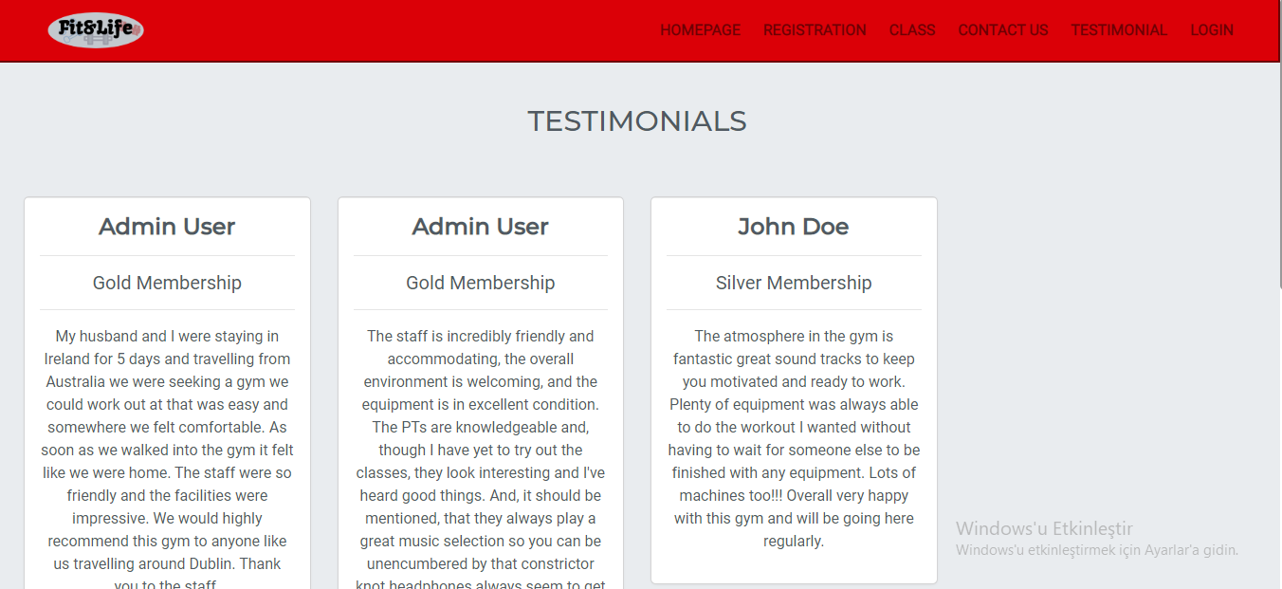

Contact Us
Contact us, we are getting some information about the people and their messages. We tried to keep simple and clean the Contact Us page.
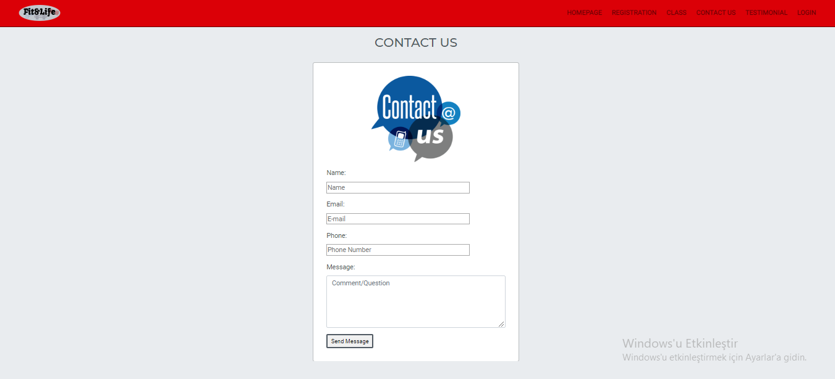

Additional pages
Here is a Login section as a Admin. We entering username and password before access as a Admin
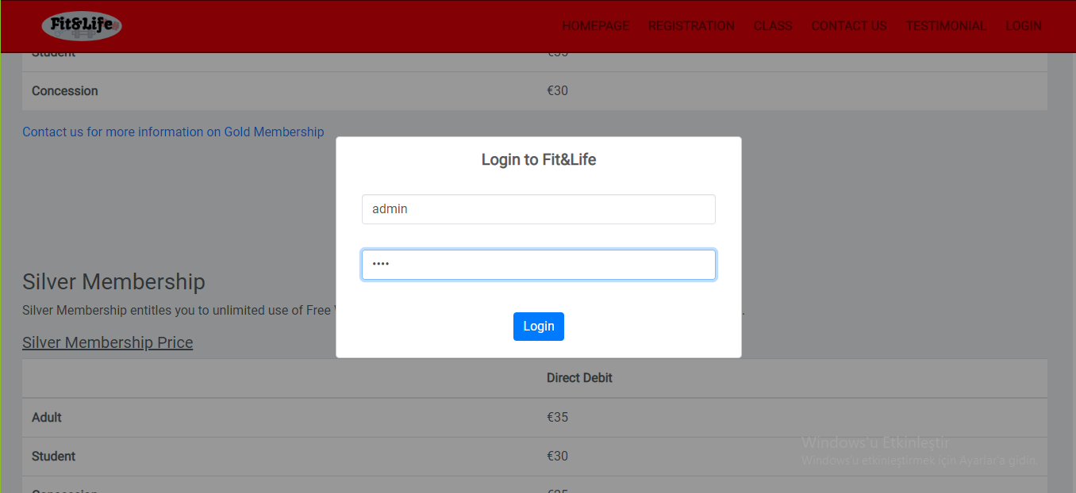
This feedback message shows to Admin Logged in successfully to page.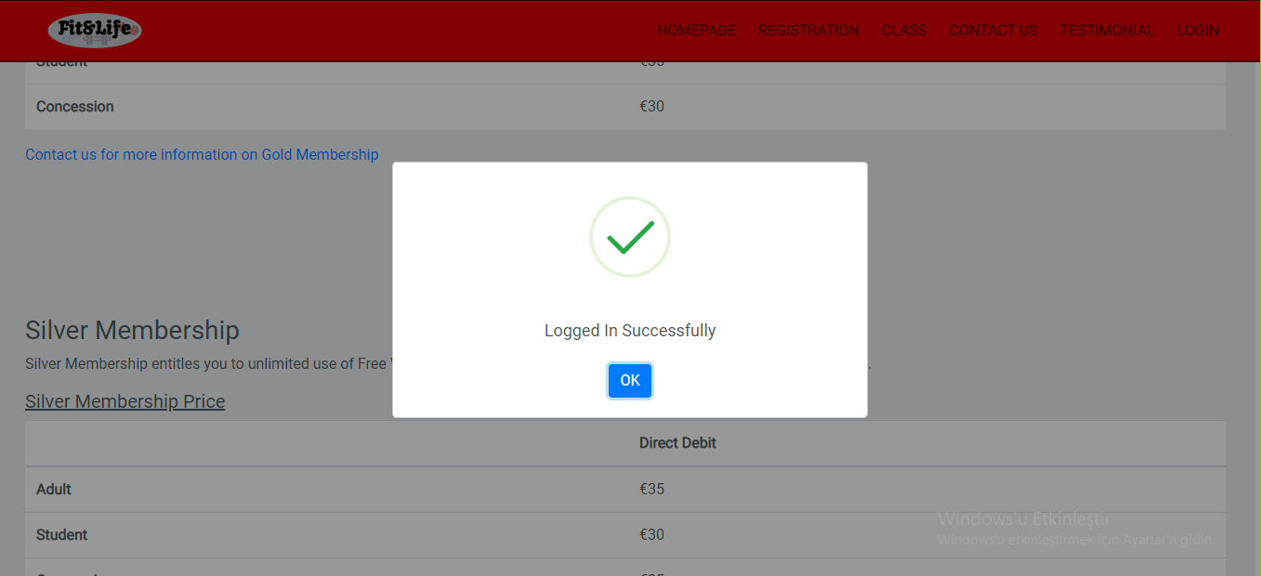
Memberships Section. This part just viewable by admin. We can Edit-Add-Delete Membership to our page.
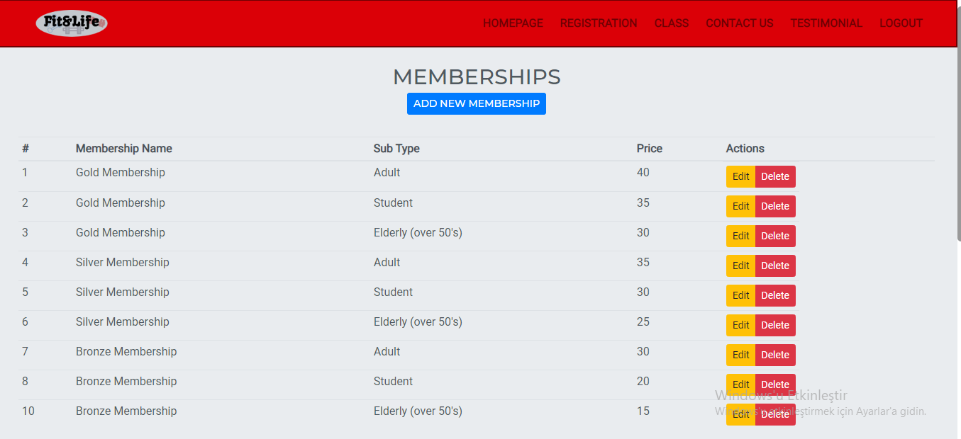
Here is just a normal person(not a member) view. S/he can register to the fit&life by choosing three different option (Bronze-Silver-Gold Membership)
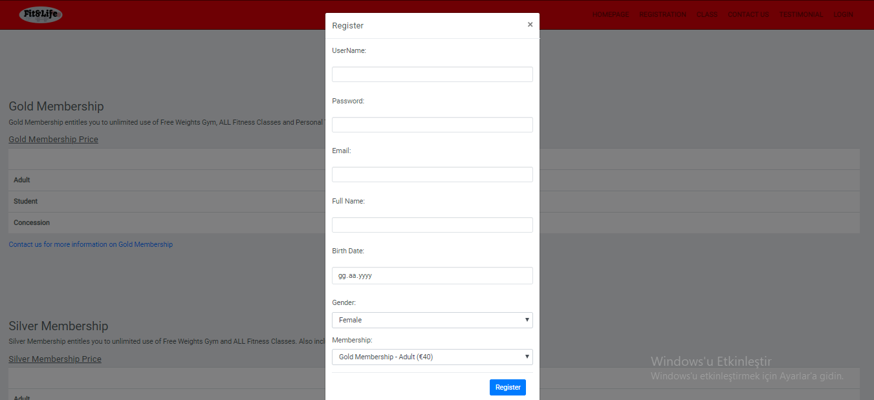
Testimonials, Admin able to show which testimonials will be shown on page.
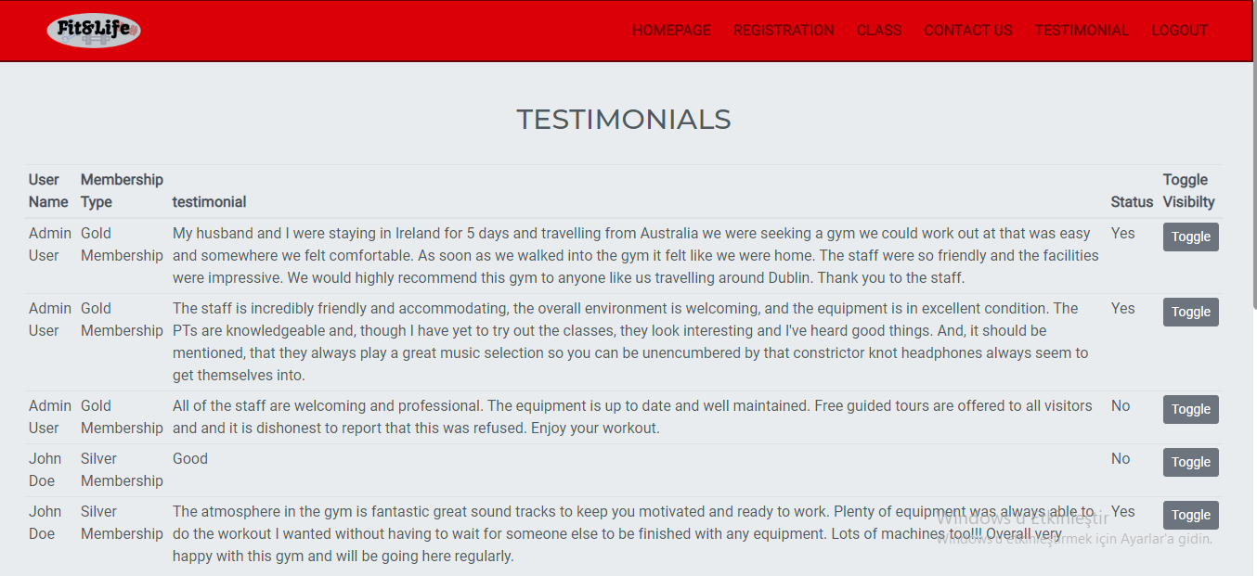

Extra features and improvements, if any
Here is a screenshot of Responsive Version(Mobile friendly).
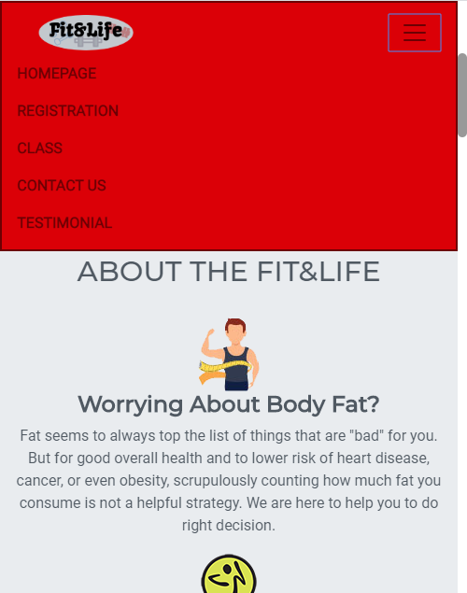
You can enter specifically page for the classes(Pilates, Zumba etc.)

Here is a custom scrollbar that we did.


Extra features and improvements, if any
Features that we attempt | Description
data-spy="scroll"  data-target="#menu” | We tried to show the heading in the navigation bar by using data-spy when we scroll down the page it was going to show the which heading are we at but since all headings are in different webpage we decided not to use it.
SweetAlert2 | We used our pop-up boxes customization by using SweetAlert2 Library that we used to create login pop-up’s.
Bootstrap | We used Bootstrap to have a better view for our website. (spacing, padding, card, button and more…)
CSS | We used Cascading Style Sheet(CSS). Navigation bar-Footer colouring, designing, and forming the pages was a main role.
MySQL | r adding, accessing, and managing content in a database. It is most noted for its quick. It was an essential part for PHP.
HTML | We used to HTML for building our skeleton for the pages.

Link to Knuth deployment
Link to Knuth:
https://knuth.griffith.ie/~s2990074/fitandlife/index.php
Admin:
Username: admin
Password: 1234
Member:
Username: johndoe
Password: 1234

Set up instructions
- Need a browser to log in our website.
- Need an open source software like FileZilla or PuTTY
- Need a link for connection (Knuth Link)
- Need to enter the link on these open source softwares.
- If you have all four you are fine. If you want to create your own database you can use phpMyAdmin

ERD of Final Database Design
Database
The project requires a database to store all of the information that we receive from the public users and members of our fitness centre website which later the admin can change or add to the database.
Rules for the database:
1. Every member should have membership.
2. Members pay for membership.
3. Members can write Testimonials.
4. Admin approves Testimonials.
5. Members must choose classes they wish to sign up for.
6. The number of classes members can choose depends on their membership.
7. Members must continue to pay fees to have membership.

Assumptions:
1. Members must pay on a monthly or yearly basis to continue to be members of the fitness centre.
2. The amount of classes a member can choose depends on their membership.
3. Each membership type has unique classes.
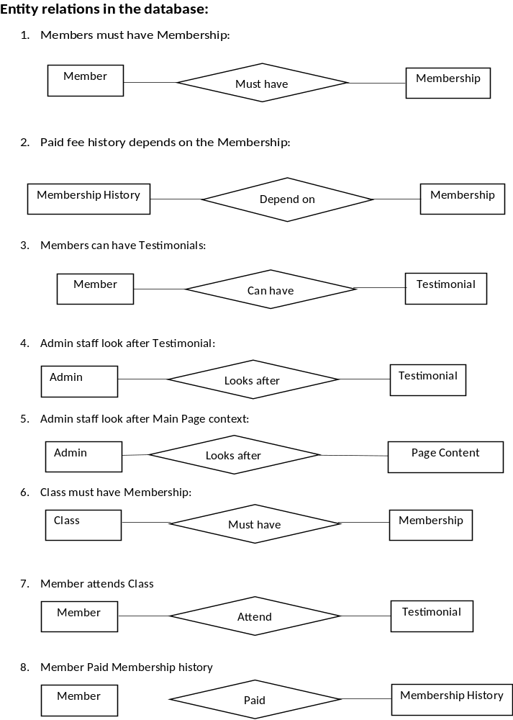
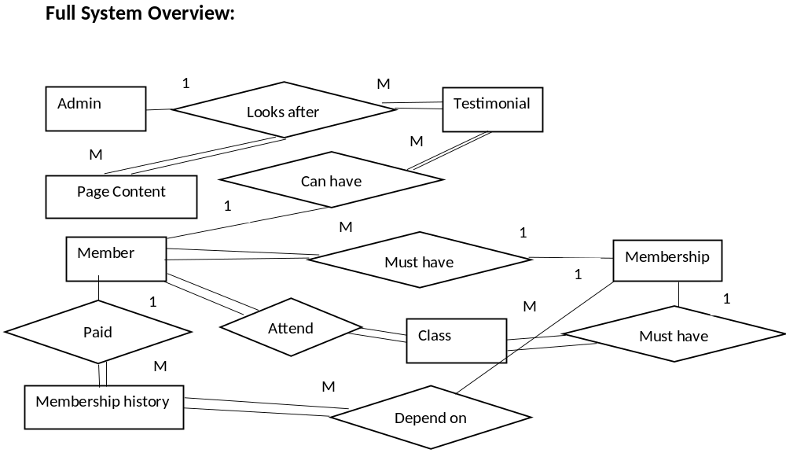

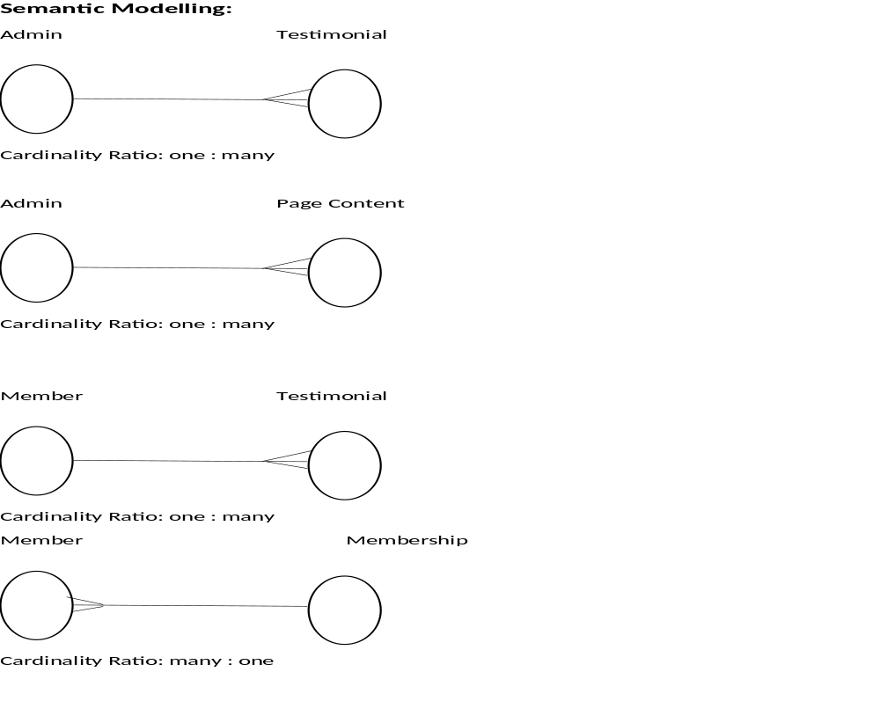

Entity Attributes:
Member {member_id, first_name, last_name, address, phone_number, email, registration_date, password, username},
Membership {membership_id, membership_name, fee_amount, start_date, end_date},
Membership_history {history_id, paid_date, amount},
Class {class_id, name, description},
Testimonial {testimonial_id, comment_text, comment_date, comment_title},
Admin {admin_id, user_name, password, first_name, last_name, phone_number, email},
Page_content {page_id, title, content, image_link, additional_content, additional_link}

Normalisation:
1st Normal form violated when a record type does not contain the same number of fields.
Not violated
2nd Normal form is violated when a non-key field is a fact about a subset of key.
Not violated

3rd Normal form is violated when a non-key field is a fact about another non-key field.
In Entity: Member the non-key field password is fact about another non-key field username, adding new Entity: Login
Login{ login_id, username, password, token},
Member {member_id, first_name, last_name, address, phone_number, email, registration_date, login_id}

Mapping an E /R Model to Relations (tables):

Entity: Member to Entity: Membership as Many : One relation and Member is Mandatory means that primary attribute membership_id in Membership as foreign key in Entity: Member
Member {member_id, first_name, last_name, address, phone_number, email, registration_date, login_id, membership_id}

Entity: Membership_history to Entity: Membership as Many : One relation means that primary attribute membership_id in Membership as foreign key in Entity: Membership_history
Entity: Membership_history to Entity: Member as Many : One relation means that primary attribute member_id in Member as foreign key in Entity: Membership_history
Membership_history {history_id, paid_date, amount, membership_id, member_id },

Entity: Testimonial to Entity: Member as Many : One relation means that primary attribute member_id in Member as foreign key in Entity: Testimonial
Entity: Testimonial to Entity: Admin as Many : One relation means that primary attribute admin_id in Admin as foreign key in Entity: Testimonial

Testimonial {testimonial_id, comment_text, comment_date, comment_title, member_id, admin_id},

Entity: Class to Entity: Membership as Many : One relation means that primary attribute membership_id in Membership as foreign key in Entity: Class
Class {class_id, name, description, membership_id},
Entity: Class to Entity: Member as Many : Many relations to solve this requires to add additional Entity:
Member_Class{ member_id, class_id}
Entity: Page_content to Entity: Admin as Many : One relation means that primary attribute admin_id in Admin as foreign key in Entity: Page_content
Page_content {page_id, title, content, image_link, additional_content, additional_link, admin_id}

Full Overview Tables:

Login{ login_id, username, password, token},
Member {member_id, first_name, last_name, address, phone_number, email, registration_date, login_id, membership_id}
Membership {membership_id, membership_name, fee_amount, start_date, end_date},
Membership_history {history_id, paid_date, amount, membership_id, member_id },
Class {class_id, name, description, membership_id},
Member_Class{ member_id, class_id}
Testimonial {testimonial_id, comment_text, comment_date, comment_title, member_id, admin_id},
Admin {admin_id, user_name, password, first_name, last_name, phone_number, email},
Page_content {page_id, title, content, image_link, additional_content, additional_link, admin_id}

Site Map of Final Website
Site Map:
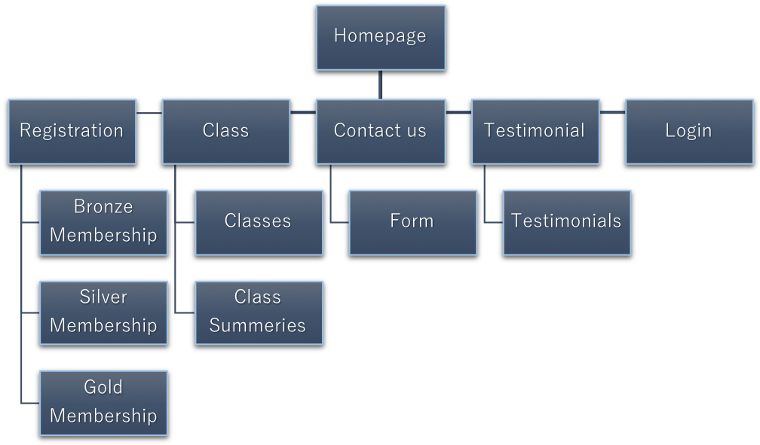
Wireframe:
This is our index.html which is ‘Homepage’. With a big landing section on top and some information at down of the page.
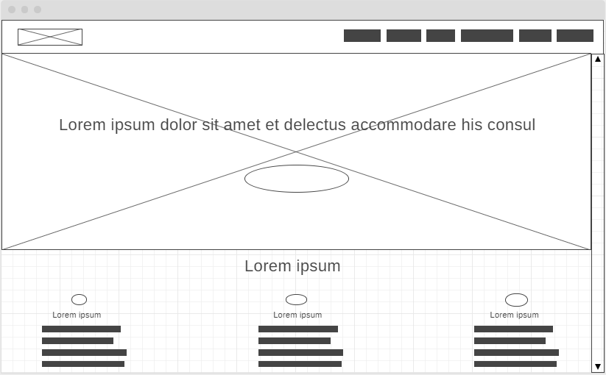
This is our registration.html. We are showing the membership packages and a big heading at top. It is going to be three section.
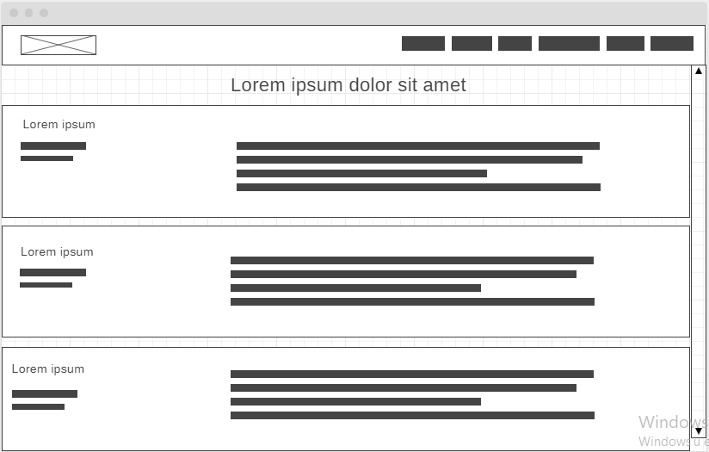

Division of Labour
Please complete the sections below regarding the estimate of the division of work between the 3 team members.

Summary of division of work
If the work was split in the range of 25% to 40% per team member then that is fine and simply say “Work was evenly divided”. If this was not the case, then state with a summary sentence.
Division of work: work was evenly divided

Percentage of work completed by each partner on each class / task
Some area requires more work than others, so this is only for reference.
Fit&Life | Mert Kaya | Oguz Sarac | Sergey Kurapov
Planning the structure | 33.33% | 33.33% | 33.33%
Diagram Design | 30% | 35% | 35%
HTML | 40% | 40% | 20%
CSS | 30% | 40% | 30%
Php | 33.33% | 33.33% | 33.33%
Database | 25% | 25% | 50%
Reviewing the code | 33.33% | 33.33% | 33.33%
Formatting the code | 33.33% | 33.33% | 33.33%

Mert Kaya | Oguz Sarac | Sergey Kurapov
(CSS)  header.php  footer.html  index.php  index_edit.php  add_feature.php  edit_feature.php  delete_feature.php  class.php  class_detail.php  class_detail_edit.php | (CSS)  registration.php  registration_edit.php  register_table.php  register.php  add_membership.php  delete_membership.php  edit_membership.php  contact_us.php  contact_us_manage.php  message_add.php | (CSS)  testimonial.php  testimonial_add.php  testimonial_add_script.php  testimional_manage.php  testimonial_manage_toggle.php  db.php  mysql_dump.sql  login.php  global.js

